1. **Population Prediction:**

**A1. Prediction Methods:** Dropdown: *Time series-based analysis, ~~Machine learning based methods~~, Scenario-based modelling, Cohort Component Method*

**If *‘Time series-based analysis’,* method is selected:**

**A1. a.i. Inputs:**

1. **Level-** Dropdown: District, Sub-district/Tehsil, Ward, Village
2. **Name of Region: ……….** (Automatically fill by typing the initial spell of the location, which is already saved), and one *‘Other’* option is provided.

***Other:*** Name will be entered, which location will be searched on Google Earth, or any other portal to search the coordinates of this location, and automatically found the ‘Region’ of its closest proximity, which *‘Demographic Attributes’* will be automatically selected for writing under the third variable, in the backend.

1. **Base Year:** Dropdown: (Years)
2. **Demographic Attributes:** Autofill but editable: (i) Annual Birth Rate, (ii) Annual Death Rate, (iii) Annual Emigration, (iv) Annual Immigration
3. **Demographic Attributes:** Autofill but editable (*Base Year Population*)
4. **Target Year / Range of Years:** Manual Entry
5. **Method for Projection-** Dropdown: *Arithmetic Increase Method, Geometric Increase Method, Logistic growth method, Exponential Growth Method*

**A1.a. ii. Processing:**

1. **If under the ‘Method for Projection’, ‘***Arithmetic Increase Method’* is selected:

**Step 1 (a):** Compute the Effective Growth Factor (G*e*):

Number of years from the base year to last available data year (n): Year of the last available data – Base Year.

Birth Rate from the Base Year to last available data year: BRb, BRb+1, BRb+2, …., BRn

Death Rate from the Base Year to last available data year: DRb, DRb+1, DRb+2, ……,DRn

Emigration Rate from the Base Year to last available data year: ERb, ERb+1, ERb+2,……, ERn

Immigration Rate from the Base Year to last available data year: IRb, IRb+1, IRb+2,….., IRn

Effective Birth Rate (BRe):

Effective Death Rate (DRe):

Effective Emigration Rate (ERe):

Effective Immigration Rate (IRe):

Effective Growth Rate **(**G*e*) *=* (BRe + IRe) – (DRe + ERe)

**Step 1 (b):** Compute the Effective Growth Factor (G*e*):

Number of years from the base year to last available data year (n): Year of the last available data – Base Year.

Annual Growth Rate from base year to next subsequent year and upto last available data year: G1, G2, G3, ………..Gn

Here, G1 = Population(Base Year +1) – Population(Base Year)

G2 = Population(Base Year +2) – Population(Base Year+1)

……………………………………………………………………………

Gn = Population of the last available data – Population of the previous year to last available data

Effective Growth Factor, G*e* =

**Step 2:** Target Year Population (P):

P*T* = PL + N.G*e*;

where, PL is the population of last available data year (Will be provided in the Data), N is number of year (N = Target Year – Year of the last available data)

***If*** only one year is selected, then compute only for the target year.

***Else*** in the case of range of years (eg. Year*i* – Year*f*) iterate the process for all the years in between Year*i* – Year*f.* Year*i* is the initial year (ith Year) and Year*f* is the final year (fth Year).

P*i* = PL + (Year*i* – Year of the last available data). G*e*

P (*i+1)* = PL + (Year(*i+1)* – Year of the last available data). G*e*

………………………………………..

………………………………………..

Pf = PL + (Yearf – Year of the last available data). G*e*

1. **If under the ‘Method for Projection’,** *‘Geometric Increase Method’* is selected:

**Step 1 (a):** Compute the Effective Growth Factor (G*e*):

Years from the base year to last available data year (n): Year of the last available data – Base Year.

Birth Rate from the Base Year to last available data year: BRb, BRb+1, BRb+2, …., BRn

Death Rate from the Base Year to last available data year: DRb, DRb+1, DRb+2, ……,DRn

Emigration Rate from the Base Year to last available data year: ERb, ERb+1, ERb+2,……, ERn

Immigration Rate from the Base Year to last available data year: IRb, IRb+1, IRb+2,….., IRn

Effective Birth Rate (BRe):

Effective Death Rate (DRe):

Effective Emigration Rate (ERe):

Effective Immigration Rate (IRe):

Effective Growth Rate **(**G*e*) *=* (BRe + IRe) – (DRe + ERe)

**Step 1 (b):** Compute the Effective Growth Factor (G*e*):

Number of years from the base year to last available data year (n): Year of the last available data – Base Year.

Annual Growth Rate from base year to next subsequent year and upto last available data year: G1, G2, G3, ………..Gn

Here, G1 = Population(Base Year +1) – Population(Base Year)

G2 = Population(Base Year +2) – Population(Base Year+1)

……………………………………………………………………………

Gn = Population of the last available data – Population of the previous year to last available data

Effective Growth Factor, G*e* =

**Step 2:** Target Year Population (P):

P*T* = PL;

where, PL is the population of last available data year (Will be provided in the Data), N is number of year (N = Target Year – Year of the last available data)

***If*** only one year is selected, then compute only for the target year.

***Else*** in the case of range of years (eg. Year*i* – Year*f*) iterate the process for all the years in between Year*i* – Year*f.* Year*i* is the initial year (ith Year) and Year*f* is the final year (fth Year) .

P*i* = PL

P (*i+1)* = PL

………………………………………..

………………………………………..

P*f* = PL

1. **If under the ‘Method for Projection’, ‘***Logistic growth method’* is selected:

**Step 1:** Detect the base year (to) population and save it as Po

**Step 2:** Detect the population for next decade (t1 = 10 years after base year) and save it as P1 (*In case of unavailability of the data, compute it based on the geometric increase method*)

**Step 3:** Detect the population for next-to-next decade (t2 = 20 years after base year) and save it as P2 (*In case of unavailability of the data, compute it based on the geometric increase method*)

**Step 4:** Compute the Saturated Population (Ps):

**Step 5:** Computation of the constant ‘m’:

$$m= \frac{P_{s}- P_{o}}{P_{o}}$$

**Step 6:** Computation of the constant ‘n’:

$n= \frac{2.3}{t_{1}}\log_{e}\left\{\frac{P_{o}.\left(P_{s}-P_{1}\right)}{P_{1}.\left(P_{s}-P_{o}\right)}\right\}$

**Step 7 (a): If population of only one target is required:**

Computation of the target year population (PT):

Year Gap (t) = Target Year – Base Year

$P_{T}= \frac{P_{s}}{1+m. \log_{e}^{-1}\left(n.t\right) }$

**Step 7 (b): If population for the ranges of years (Year*i* – Year*f*):**

Year Gap (ti) = Initial Yeari – Base Year

Year Gap (ti+1) = Initial Yeari+1 – Base Year

Year Gap (ti+2) = Initial Yeari+2 – Base Year

……………………………………………..

Year Gap (tf) = Final Yearf – Base Year

Population for the initial year Year*i* (Pi):

Population for the initial year Year*i+1* (Pi+1):

Similarly, Population for the final year Year*f* (Pf):

1. **If under the ‘Method for Projection’, ‘***Exponential Growth Method’* is selected:

**Step 1:** Save the base year population as Po

**Step 2 (a):** Time (t) = Target Year – Base Year (In case of single target year)

**Step 2 (b):** ti = Yeari - Base Year; t(i+1) = Year(i+1) - Base Year;……..tf = Yearf - Base Year

**Step 3:** Computation of the growth rate (r) = $\frac{n.\sum{xy}- \sum{x}.\sum{y}}{n.\sum{x^{2}}-{\left(\sum{x}\right)}^{2}}$

**Table**: Sample Table for the computation of growth rate (r),

|  |  |  |  |  |  |  |
| --- | --- | --- | --- | --- | --- | --- |
| SN | Yeari | Population  (Pi) | x  (t = Yeari – Base Year) | y  (Log Pi) | x.y | x2 |
|  | 1981 | 1000000 | 0 | 13.81551 | 0 | 0 |
|  | 1991 | 1200000 | 10 | 13.99783 | 139.9783 | 100 |
|  | 2001 | 1500000 | 20 | 14.22098 | 284.4195 | 400 |
|  | 2011 | 1800000 | 30 | 14.4033 | 432.0989 | 900 |
| n = 4 | Total - | | $$\sum{x}=60$$ | $$\sum{y}=56.43$$ | $$\sum{xy}=856.49$$ | $$\sum{x^{2}}=1400$$ |

*(If base year is 1981, and last available data year is 2011)*

So, in the above case, growth rate (r) will be calculated by putting all the values generated from the table in the equation under *Step 3.*

**Step 4 (a): If population of only one target is required:**

${Target Year Population (P}_{t})= P_{o}.e^{r.t}$

**Step 4 (b):** **If population for the ranges of years (Year*i* – Year*f*):**

**A1.a.iii. Output:**

**If only one target year is selected:**

Print: “Projected Population for the Year (‘Target Year’) is: P*T*”

**If range of the years are selected ( Year*i* – Year*f*):**

Print: “Projected Population for the Period **Year*i* – Year*f*** is:

|  |  |
| --- | --- |
| **Year** | **Population** |
| Year*i* | P*i* |
| Year*(i+1)* | P*(i+1)* |
| …….. | ……. |
| …….. | ……. |
| Year*f* | P*f* |

**If *‘Machine learning based methods’,* method is selected:**

**A1. b.i. Inputs:**

1. **Level-** Dropdown: District, Sub-district/Tehsil, Ward, Village
2. **Name of Region: ……….** (Automatically fill by typing the initial spell of the location, which is already saved), and one *‘Other’* option is provided.

***Other:*** Name will be entered, which location will be searched on Google Earth, or any other portal to search the coordinates of this location, and automatically found the ‘Region’ of its closest proximity, which *‘Demographic Attributes’* will be automatically selected for writing under the third variable, in the backend.

1. **Target Year / Range of Years:** Manual Entry

**A1.b. ii. Processing:**

* Split the whole population data into 70:30 for the training and testing.
* Train the model (ANN) using 70% of training data.
* Test the model using 30% of the testing data.
* Predict the Population for the target year (P*T*) or range of the years (P*i* – P*f*).

**A1.b.iii. Output:**

**If only one target year is selected:**

Print: “Projected Population for the Year (‘Target Year’) is: P*T*”

**If range of the years are selected ( Year*i* – Year*f*):**

Print: “Projected Population for the Period **Year*i* – Year*f*** is:

|  |  |
| --- | --- |
| **Year** | **Population** |
| Year*i* | P*i* |
| Year*(i+1)* | P*(i+1)* |
| …….. | ……. |
| …….. | ……. |
| Year*f* | P*f* |

**If *‘Scenario-based modelling’,* method is selected:**

**A1. c.i. Inputs:**

1. **Level-** Dropdown: District, Sub-district/Tehsil, Ward, Village
2. **Name of Region: ……….** (Automatically fill by typing the initial spell of the location, which is already saved), and one *‘Other’* option is provided.

***Other:*** Name will be entered, which location will be searched on Google Earth, or any other portal to search the coordinates of this location, and automatically found the ‘Region’ of its closest proximity, which *‘Demographic Attributes’* will be automatically selected for writing under the third variable, in the backend.

1. **Base Years:** Dropdown: (Years)
2. **Target Year / Range of Years:** Manual Entry
3. **User Defined Scenario:**
   1. Annual Birth Rate Change (%):……..(Manual Entry)
   2. Annual Death Rate Change (%)……..(Manual Entry)
   3. Annual Emigration Rate Change (%)……..(Manual Entry)
   4. Annual Immigration Rate Change (%) ……..(Manual Entry)

**A1. c.ii. Processing:**

**Step 1:** Compute the Effective Growth Factor (G*e*):

Years from the base year to last available data year (n): Year of the last available data – Base Year.

Birth Rate from the Base Year to last available data year: BRb, BRb+1, BRb+2, …., BRn

Death Rate from the Base Year to last available data year: DRb, DRb+1, DRb+2, ……,DRn

Emigration Rate from the Base Year to last available data year: ERb, ERb+1, ERb+2,……, ERn

Immigration Rate from the Base Year to last available data year: IRb, IRb+1, IRb+2,….., IRn

Effective Birth Rate (BRe):

Effective Death Rate (DRe):

Effective Emigration Rate (ERe):

Effective Immigration Rate (IRe):

Scenario based Birth Rate (BR*scen*) = Effective Birth Rate (BRe ) + (Effective Birth Rate (BRe ) X Annual Birth Rate Change %)

Scenario based Death Rate (DR*scen*) = Effective Death Rate (DRe ) + (Effective Death Rate (DRe ) X Annual Death Rate Change %)

Scenario based Emigration Rate (ER*scen*) = Effective Emigration Rate (ERe ) + (Effective Emigration Rate (ERe ) X Annual Emigration Rate Change %)

Scenario based Immigration Rate (IR*scen*) = Effective Immigration Rate (IRe ) + (Effective Immigration Rate (IRe ) X Annual Immigration Rate Change %)

Scenario based Growth Rate **(**G*scen*) *=* (BR*scen* + IR*scen*) – (DR*scen* + ER*scen*)

**Step 2:** Target Year Population (P):

P*T* = PL;

where, PL is the population of last available data year (Will be provided in the Data), N is number of year (N = Target Year – Year of the last available data)

***If*** only one year is selected, then compute only for the target year.

***Else*** in the case of range of years (eg. Year*i* – Year*f*) iterate the process for all the years in between Year*i* – Year*f.* Year*i* is the initial year (ith Year) and Year*f* is the final year (fth Year) .

P*i* = PL

P (*i+1)* = PL

………………………………………..

………………………………………..

P*f* = PL

**A1.c.iii. Output:**

**If only one target year is selected:**

Print: “Projected Population for the Year (‘Target Year’) is: P*T*”

**If range of the years are selected ( Year*i* – Year*f*):**

Print: “Projected Population for the Period **Year*i* – Year*f*** is:

|  |  |
| --- | --- |
| **Year** | **Population** |
| Year*i* | P*i* |
| Year*(i+1)* | P*(i+1)* |
| …….. | ……. |
| …….. | ……. |
| Year*f* | P*f* |

**If ‘Cohort Component Method’ is selected:**

**A1. d.i. Inputs:**

1. **Level-** Dropdown: District, Sub-district/Tehsil, Ward, Village
2. **Name of Region: ……….** (Automatically fill by typing the initial spell of the location, which is already saved), and one *‘Other’* option is provided.

***Other:*** Name will be entered, which location will be searched on Google Earth, or any other portal to search the coordinates of this location, and automatically found the ‘Region’ of its closest proximity, which *‘Demographic Attributes’* will be automatically selected for writing under the third variable, in the backend.

1. **Base Years:** Dropdown: (Years)
2. **Target Year / Range of Years:** Manual Entry
3. **Demographic Rates:**
   1. Age-Specific Fertility Rates (ASFR): Auto Upload / Manual Entry
   2. Age-Specific Mortality Rates (ASMR): Auto Upload / Manual Entry
   3. Age-Specific Migration Rates (ASMR): Auto Upload / Manual Entry
   4. Sex Ratio in %: Auto Upload / Manual Entry

**A1. d.ii. Processing:**

1. ***Age Groups:*** Divide the base year population into 5-year age cohorts (e.g., 0-4, 5-9, ..., 80+).
2. ***Sex Segregation:*** Separate each age cohort by sex.

***(c) Calculate age specific survival rate for both male and female:***

**Age and Gender Specific Survival Rate**

**= ${(1-Annual Per Capita Mortality Rate)}^{n}$**

Here ‘n’ is the interval of the age group (eg. 5 years, if 0-4, 5-9….., 85+)

***(d) Birth Estimation in the next projected year (Suppose base year is 2011, then it will be for 2016):***

**Numbers of Births during the fertile ages =**

Numbers of females during each fertile age group (Ex. 15-19, 20-24, 25-29, ….45-49 years) $×$ Annual fertility rate in that age group $× Y$ ear Interval (Ex. Suppose base year is 2011, and next projected year is 2016, then it will be 5 for 2011-2016)

**Total Births (TB) = $\sum_{i=15-19}^{45-49}{Numbers of Births during the each fertile age group}$**

**Sex Ratio = x% (Given)**

It means x% of the total are females, and (100-x)% are males.

**Number of Males in the first cohort (0-4) in the next projected year (Ex. 2016):**

= TB $×$ $\frac{(100-X)}{100}$

**Number of Females in the first cohort (0-4) in the next projected year (Ex. 2016):**

= TB $×$ $\frac{(X)}{100}$

**Number of Males in the second cohort (5-9) in the next projected year (Ex. 2016):**

**=** Number of Males in the first cohort (0-4) in the base year (Ex. 2011) $×$ Survival Rate of the males of the first cohort (0-4) in the base year (Ex. 2011)

**Number of Females in the second cohort (5-9) in the next projected year (Ex. 2016):**

**=** Number of females in the first cohort (0-4) in the base year (Ex. 2011) $×$ Survival Rate of the females of the first cohort (0-4) in the base year (Ex. 2011)

**……………………………………………………………………………………**

**……………………………………………………………………………………**

**Number of Males in the last cohort (Ex. 85+) in the next projected year (Ex. 2016):**

**= (**Number of Males in the second last cohort (80-84) in the base year (Ex. 2011) $×$ Survival Rate of the males of the second last cohort (80-84) in the base year (Ex. 2011)) + (Number of Males in the last cohort (85+) in the base year (Ex. 2011) $×$ Survival Rate of the males of the last cohort (85+) in the base year (Ex. 2011))

**Number of Females in the last cohort (Ex. 85+) in the next projected year (Ex. 2016):**

**= (**Number of females in the second last cohort (80-84) in the base year (Ex. 2011) $×$ Survival Rate of the females of the second last cohort (80-84) in the base year (Ex. 2011)) + (Number of females in the last cohort (85+) in the base year (Ex. 2011) $×$ Survival Rate of the females of the last cohort (85+) in the base year (Ex. 2011))

***(e) Computation of the migration-adjusted population:***

Number of the projected population in each cohort (section (e)) **+** Age-Specific Migration Rates (ASMR)

1. ***Iterate the same process if range of years is provided (eg. 2016, 2021, 2026, 2031 etc.)***

**A1. d.iii. Output:**

**If Single Target Year:** Display the projected population for the specified target year, broken down by age and sex cohorts like:

Projected Population for the Year *“Target Year”*:

* + Age Group 0-4: Males: ……..; Females: ………
  + Age Group 5-9: Males: ……..; Females: ………
  + …………………………………………………..
  + Age Group 80+: Males: ……..; Females: ………

**If range of year is selected:** Present a table showing projected populations for each year within the range, detailed by age and sex cohorts.

|  |  |  |  |  |  |  |  |  |
| --- | --- | --- | --- | --- | --- | --- | --- | --- |
| **Age Group**  **(Years)** | **Year*i*** | | **Year*i+5*** | | **…..** | | **Year*f*** | |
| **Males** | **Females** | **Males** | **Females** | **Males** | **Females** | **Males** | **Females** |
| 0-4 | … | … | … | … | … | … | … | … |
| 5-9 | … | … | … | … | … | … | … | … |
| … | … | … | … | … | … | … | … | … |
| … | … | … | … | … | … | … | … | … |
| 80+ | … | … | … | … | … | … | … | … |

1. **Water Demand Estimation and Prediction:**

**B1. Water Demand Estimation Types-** *Dropdown:* *Domestic Demand,* *Floating Population Demand, Institutional Demand, Fire Fighting Demand, Total Water Demand*

**If *‘Domestic Demand’,* method is selected:**

**B1. a.i. Inputs:**

1. **Level -** Dropdown: District, Sub-district/Tehsil, Ward, Village
2. **Name of Region: ……….** (Automatically fill by typing the initial spell of the location, which is already saved), and one *‘Other’* option is provided.

***Other:*** Name will be entered, which location will be searched on Google Earth, or any other portal to search the coordinates of this location, and automatically found the ‘Region’ of its closest proximity, which *‘Population’* will be automatically selected for writing under the third variable, in the back end.

1. **Year:** Dropdown: Years
2. **Population:** Autofill the population of the selected year based on the saved data (but editable)

**B1. a.ii. Processing:**

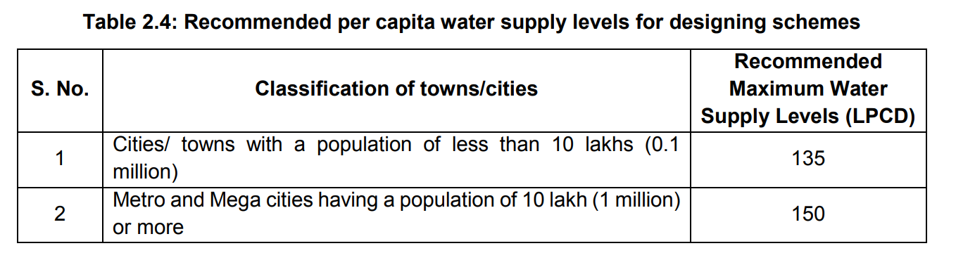

***Source: CPHEEO Manual, 2024***

If **Population** is ≥ 1,000,000: Then, Water Demand = (Population ×150)

If **Population** is < 1,000,000: Then, Water Demand = (Population ×135)

**B1. a.iii. Output:**

**Pop-up: Total Water Demand by the “*Name of Region*” is “*Water Demand***” **LD.**

**If *‘Floating Population Demand’,* method is selected:**

**B1. b.i. Inputs**

1. **Level-** Dropdown: District, Sub-district/Tehsil, Ward, Village
2. **Name of Region: ……….** (Automatically fill by typing the initial spell of the location, which is already saved), and one *‘Other’* option is provided.

***Other:*** Name will be entered, which location will be searched on Google Earth, or any other portal to search the coordinates of this location, and automatically found the ‘Region’ of its closest proximity, which *‘****Floating Population’***will be automatically

1. **Floating Population:** Fill Automatically (But Editable)
2. **Facility- Check anyone:** *Bathing facilities provided, Bathing facilities not provided, Floating population using only public facilities*

**B1. b.ii. Processing:**

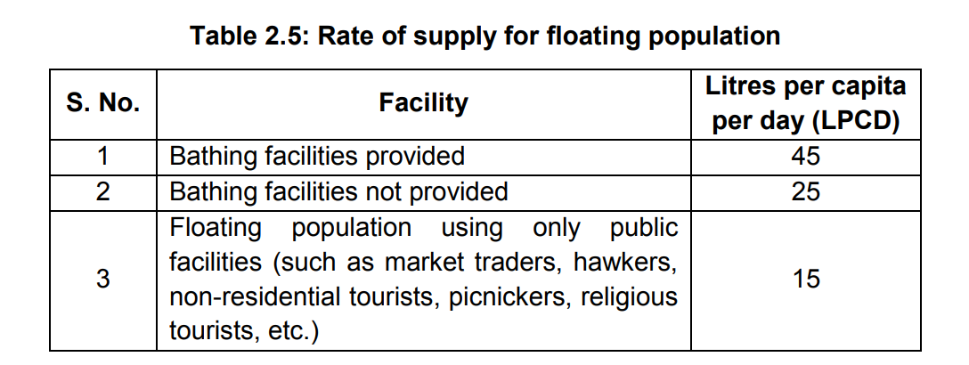

***Source: CPHEEO Manual, 2024***

1. **If “*Bathing facilities provided”* is checked:**

Floating Population Water Demand: “**Floating Population” × 45**

1. **If “*Bathing facilities not provided”* is checked:**

Floating Population Water Demand: “**Floating Population” × 25**

1. **If “*Floating population using only public facilities”* is checked:**

Floating Population Water Demand: “**Floating Population” × 15**

**B1. b.iii. Output:**

**Pop-up: Total Water Demand by the Floating Population in the “*Name of Region*” is “*Floating Population Water Demand***” **LD.**

**If *‘Institutional Demand’,* method is selected:**

**B1. c.i. Inputs:**

1. **Level-** Dropdown: District, Sub-district/Tehsil, Ward, Village
2. **Name of Region: ……….** (Automatically fill by typing the initial spell of the location, which is already saved), and one *‘Other’* option is provided.

***Other:*** Name will be manually entered

1. **Institutional Status:**
2. Number of Hospitals (including laundry):
   1. Hospitals with more than or equal to 100 Beds:……
      1. Number of Beds:……
   2. Hospitals with less than 100 Beds:……
      1. Number of Beds:……
3. Number of Hotels:…..
   * 1. Number of Beds:……
4. Number of Hostels:……
   * 1. Number of Residents:……
5. Number of Nurses’ homes and medical quarters:…..
   * 1. Number of Residents:……
6. Number of Boarding schools / colleges:……….
   * 1. Number of Students:……
7. Number of Restaurants:…..
   * 1. Number of Seats:……
8. Number of Airports and seaports:……
   * 1. Population Load:……
9. Number of Junction Stations and intermediate stations where mail or express stoppage (both railways and bus stations) is presided:…….
   * 1. Population Load:……
10. Number of Terminal stations:…..

(a) Population Load:……

1. Number of Intermediate stations (excluding mail and express stops):
   1. With bathing facility:…….
      1. Population Load:……
   2. Without bathing facility:……
      1. Population Load:……
2. Number of Day schools / colleges:……
   * 1. Number of Students:……
3. Number of Offices:……
   * 1. Number of Employees:……
4. Number of Factories:
   1. With bathroom facility:…..
      1. Number of Employees:……
   2. Without bathroom facility:……
      1. Number of Employees:……
5. Number of Cinema, concert halls, and theatre:…..
   * 1. Population Load:……

**B1. c.ii. Processing and ouput:**

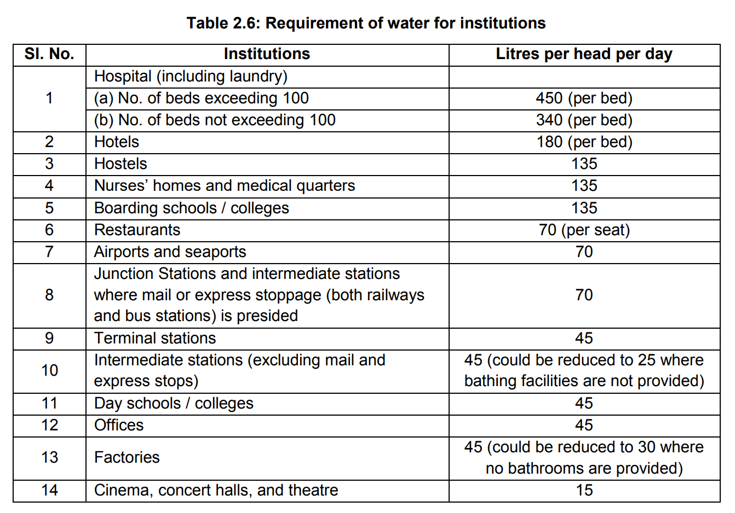

***Source: CPHEEO Manual, 2024***

***Print: Institutional water demand for the “Name of Region” is:***

|  |  |  |
| --- | --- | --- |
| **SN** | **Institute** | **Water Demand (in LD)** |
|  | Number of Hospitals (including laundry):   1. Hospitals with more than or equal to 100 Beds: 2. Hospitals with less than 100 Beds: | Number of Units $×$ Number of Beds $×$ 450  Number of Units $×$ Number of Beds $×$ 340 |
|  | Hotels | Number of Units $×$ Number of Beds $×$ 180 |
|  | Hostels | Number of Units $×$ Number of Residents $×$ 135 |
|  | Nurses’ homes and medical quarters | Number of Units $×$ Number of Residents $×$ 135 |
|  | Boarding schools / colleges | Number of Units $×$ Number of Students $×$ 135 |
|  | Restaurants | Number of Units $×$ Number of Seats $×$ 70 |
|  | Airports and seaports | Number of Units $×$ Population Load $×70$ |
|  | Junction Stations and intermediate stations where mail or express stoppage (both railways and bus stations) is presided | Number of Units $×$ Population Load $×70$ |
|  | Terminal stations | Number of Units $×$ Population Load $×45$ |
|  | Intermediate stations (excluding mail and express stops)   1. With bathing facility: 2. Without bathing facility: | Number of Units $×$ Population Load $×45$ Number of Units $×$ Population Load $×25$ |
|  | Day schools / colleges | Number of Units $×$ Number of Students $×$ 45 |
|  | Offices | Number of Units $×$ Number of Employees $×$ 45 |
|  | Factories   1. With bathroom facility: 2. Without bathroom facility: | Number of Units $×$ Number of Employees $×$ 45  Number of Units $×$ Number of Employees $×$ 30 |
|  | Cinema, concert halls, and theatre | Number of Units $×$ Population Load $×15$ |
| Total Institutional Demand | | 1 (a) + 1 (b) + 2 + 3 + 4 + 5 + 6 + 7 + 8 + 9 + 10 (a) + 10 (b) +11 + 12 + 13 (a) + 13 (b) + 14 |

**If *‘Fire Fighting Demand’,* method is selected:**

**B1. d.i. Inputs:**

1. **Level-** Dropdown: District, Sub-district/Tehsil, Ward, Village
2. **Name of Region: ……….** (Automatically fill by typing the initial spell of the location, which is already saved), and one *‘Other’* option is provided.

Other: Name will be entered, which location will be searched on Google Earth, or any other portal to search the coordinates of this location, and automatically found the ‘Region’ of its closest proximity, which ‘Population’ will be automatically selected for writing under the variable ‘Population of the Region’.

1. **Intermediate Stage:** Fill Automatically ‘*15*’ Years (But Editable)
2. **Population of the Region at Intermediate Stage:** Fill Automatically (But Editable)
3. **Name of the Operational Zone: “**Enter Name”
4. **Population of the Operational Zone at Intermediate Stage: “**Enter Manually**”**

**B1. d.ii. Processing:**

1. **Population of the Region at Intermediate Stage (P*is*) =**

Population of the last available year data $× {[1+\{\left(Annual Birth Rate of the Last Year+Annual Immigration Rate of the Last Year\right)-\left(Annual Death Rate of the Last Year+Annual Emigration Rate of the Last Year\right)\}]}^{N}$

Here, N = 15, or data provided under the ‘Intermediate Stage’ section

**OR**

Number of years from the first available year data to the last available data year (n): Yearlast –Yearfirst.

Annual Growth Rate from first year to each next subsequent year and upto last year: G1, G2, G3, ………..Gn

Here, G1 = Population(First Year +1) – Population(First Year)

G2 = Population(First Year +2) – Population(First Year+1)

……………………………………………………………………………

Gn = Population(last year) – Population(last year – 1)

Effective Growth Factor, G*e* =

Hence, Pis =

1. **Water Requirements for the Fire in the Entire Region (Wr) =**
2. **Water Requirements for the Fire in the Operational Zone, OZ (Woz) =**

**B1. d.iii. Output:**

**Pop-up:** *Fire Fighting Water Demand for the Whole Region “****Name of the Region****” is* ***“Wr”***

*Fire Fighting Water Demand for the Operational Zone “****Name of the Operational Zone****” in the Region “****Name of the Region****” is* ***“Woz”*** *LCD.*

**If *‘Total Demand’,* method is selected:**

**B1. e.i. Inputs:**

1. **Level-** Dropdown: *District, Sub-district/Tehsil, Ward, Village*
2. **Name of Region:** ………. (Automatically fill by typing the initial spell of the location, which is already saved), and one ‘Other’ option is provided.

*Other*: Name will be manually entered

1. **Enter Domestic Demand (in LD):** Enter Manually / Calculate by previous method
2. **Enter Floating Population Demand (in LD):** Enter Manually / Calculate by

previous method

1. **Enter Institutional Demand (in LD):** Enter Manually / Calculate by

previous method

1. **Enter Fire Fighting Demand (in LD):** Enter Manually / Calculate by

previous method

**B1. e.ii. Processing:**

**Gross Demand (W*gross*) =** Domestic Demand + Floating Population Demand +

Institutional Demand + Fire Fighting Demand

**Total Water Demand (WT) =**

**B1. e.iii. Output:**

**Pop-up:** *Total Water Demand in the Region* **“*Name of Region”*** *is* ***“*WT*”*** *MLD.*

1. **Sewage Load Estimation and Prediction:**

***C1.*****Methods***: Dropdown: Sector-based Estimation Method, Water Supply-based Method*

**If *‘Sector-based Estimation Method’,* method is selected:**

**C1 a.i. Inputs:**

1. **Level-** Dropdown: District, Sub-district/Tehsil, Ward, Village
2. **Name of Region: ……….** (Automatically fill by typing the initial spell of the location, which is already saved), and one *‘Other’* option is provided.

**Other:** Name will be entered, manually.

1. **Sectors-** *Dropdown: Domestic Sewage Load, Floating Population Sewage Load, Institutional Sewage Load, Fire Fighting Sewage Load, Total Sewage Load*
2. **Water Demand:** *Dropdown: Modeled, Manual*

**If *‘Modeled’* is selected**: Refer to **Section B** for the calculation of modeled water demand, and write it in MLD.

**If *‘Manual’* is selected**: Enter the value manually (in MLD)

**C1 a.ii. Processing:**

**Waste Water (WW) =** Water Demand $×$ $\frac{80}{100}$

**C1 a.iii. Output:**

Total Generated Waste Water by the *“****Sectors****”* in the *“****Name of the Region****”* is*: ‘WW’ MLD*

**If *‘Water Supply-based Method’,* method is selected:**

**C1 b.i. Inputs:**

1. **Level-** Dropdown: District, Sub-district/Tehsil, Ward, Village
2. **Name of Region: ……….** (Automatically fill by typing the initial spell of the location, which is already saved), and one *‘Other’* option is provided.

**Other:** Name will be entered, manually.

1. **Total Water Supply (In MLD):** …….(Numerical value will be manually entered)

**C1 b.ii. Processing:**

**Total Waste Water =** Total Water Supply $×$ $\frac{80}{100}$

**C1 b.iii. Output:**

Total Generated Waste Water in the *“****Name of the Region****”* is*: ‘WW’* MLD.

1. **STP Site Priority and Suitability**

**D1. STP Site Priority:**

**D1. a Inputs:**

1. ***Selection of the Target Districts***: Show all Districts under dropdown option with search option at its top, and one ‘Other’ option should also provide. While clicking on the ‘Other’ option, manual entries should be done.

***Other***

|  |
| --- |
| ***Search*** |
| * **Varanasi** |
| Prayagraj |
| * **Jaunpur** |
| Chandauli |

*Selected districts for prioritization are: Varanasi, Jaunpur*

***(ii)*** ***Selection of the prioritization factors:***

*Tick based interface:*

* Sewage Gap Mean Temperature Mean Rainfall

 Number of Tourists Number of ASI Sites GDDP at Current Price

Water Quality Index

***(iii)*** ***Values of the prioritization factors:***

*Autofill values of the selected parameters for the selected districts in the tabular format with editing option enabled, (Note: All entries will be done manually for the ‘****Other’*** *districts):*

|  |  |  |  |  |  |
| --- | --- | --- | --- | --- | --- |
| ***Districts*** | ***Sewage Gap*** | ***Mean Temperature*** | ***Mean Rainfall*** | ***Number of Tourists*** | ***Water Quality Index*** |
| Varanasi |  |  |  |  |  |
| Jaunpur |  |  |  |  |  |

***(iv) Method for prioritization:*** Dropdown: *AHP, TOPSIS*

**D1. b Processing:**

**If ‘*AHP’* method is selected under the ‘method for prioritization’:**

**If ‘*TOPSIS’* method is selected under the ‘method for prioritization’:**

**D1. c Output:**

*Show the prioritization ranks for the selected districts in the tabular format like this:*

|  |  |
| --- | --- |
| ***Districts*** | ***Priority Rank*** |
| Varanasi | 1 |
| Jaunpur | 2 |

**D2. STP Site Suitability:**

**D2. a Inputs:**

1. ***Select the region:***

**Level-** Dropdown: District, Sub-district/Tehsil, Ward, Village

**Name of Region: ……….** (Automatically fill by typing the initial spell of the location, which is already saved), and one *‘Other’* option is provided.

**Other:** Name will be entered, manually.,

*If ‘other’ option is selected:*

**Upload the Shape File:** ………Upload the shape file from the local directory.

***(ii) Selection of the Desired Conditioning Factors:***

*Tick based interface:*

* Lithology Geomorphology Soil Texture

 Soil Type Distance from built-up land Distance from road

LULC Elevation Slope Population Density

 Literacy

***(iii) Selection of the Constraints Factors:***

*Tick based interface:*

1. ***Natural Factors:***

* Water Body Slope Soil Texture

 Flood Prone Area Groundwater Depth Wetland

Forest Seismic Zones

1. ***Anthropogenic Factors:***

 Road Railway Airport

 Built-up area ASI Sites Defense Area

Existing STPs Proposed STPs

***(iv) Methods for the STP Site Suitability:*** Dropdown: *AHP, Fuzzy-AHP, DEMATLE-ANP, GRA*